# Ecommerce Challenge Guidline

1. Download project from ZIP
2. Execute DB scripts from the file **ContradoEcommerceDBScripts.sql**
   1. This contains only Stored Procedures
   2. Master DB will we created by scripts given with the challenge
3. Open project and configure as below
4. Modify **appsettings.json** file under project **ContradoChallengeAPI**
   1. Set key **SqlConnectionString** with appropriate db connection string
   2. Set key **CORSOrigin** key with website URL
      1. Website URL can be obtained by running **ECommerceDemo** project
      2. Sample Key : **"CORSOrigin":** [**https://localhost:44347**](https://localhost:44347)
5. Modify 2 Javasript files for API URL
   1. API Url can be obtain by running **ContradoChallengeAPI** project
   2. Modify below files
      1. ECommerceDemo\wwwroot\js\Products.js
      2. ECommerceDemo\wwwroot\js\productSave.js
   3. On starting of the file check for constant apiBaseURL and replace with API URL
      1. Sample value : **const apiBaseURL = '**[**https://localhost:44312**](https://localhost:44312)**';**
6. Run both **ECommerceDemo** and **ContradoChallengeAPI** project at same time to getting this project work as shown in below image

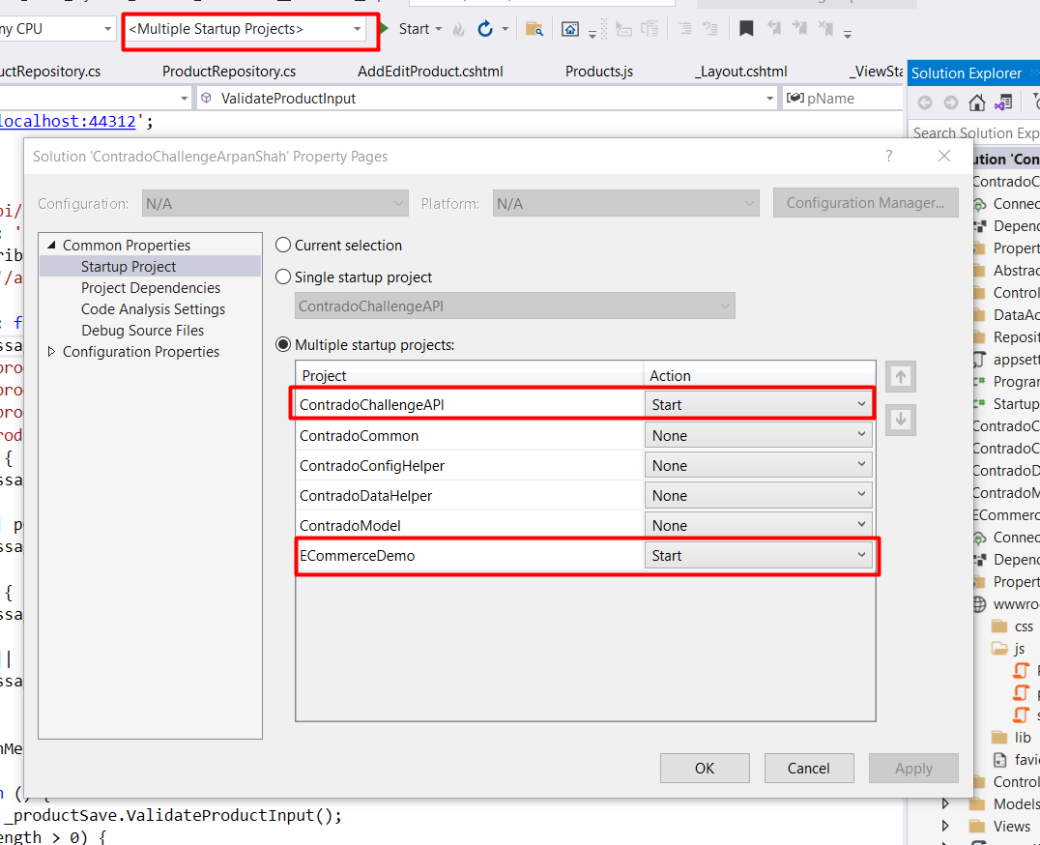

# For any Query, please contact me directly on call : **Arpan Shah - 9998796362**